CHANGES IN LAKE VICTORIA’S HYDROLOGY, WATER QUALITY, AND LIVELIHOODS

EFD-MAK POLICY BRIEF

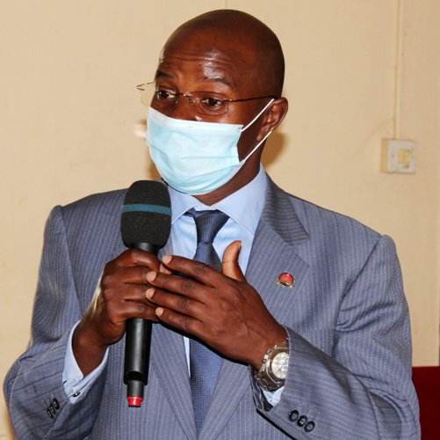
Executive Summary
Lake Victoria is a transboundary natural resource, underpinning the economies and livelihoods of the population within the wider catchment area of Burundi, Kenya, Tanzania, Rwanda and Uganda. The lake acts as a source of fresh water, fishing, a waste repository and provides food, energy, water for irrigation, industry, drinking, tourism and within and cross border transportation. However, the lake and its surrounding areas has faced many challenges including rising lake water levels, moving islands, encroachment, ecological and biodiversity degradation which is evident in the probable extinction of several fish species. It is upon this background that EfD Makerere Centre organized a one-day policy dialogue on the changes of Lake Victoria hydrology, water quality and livelihoods in Jinja District, Uganda. During the dialogue, it was noted that the buffer zone of 200 m away from the lake as requirement by NEMA has been widely violated and as a result, there is a lot of encroachment on the lake by investors, industries, farmers and settlers. Increasing pollutants in form of polythene bags, plastics and untreated wastes continue to pollute the lake. Political interferences, poor fishing methods, ineffective lake monitoring and poor implementation of the existing laws on the management and utilization of the lake were noted. The dialogue thus resolved that there should be deepened transboundary cooperation on the management of the lake, tackling point and non-point source pollution. A coherent plan for conservation and rehabilitation of the fish fauna in the Lake Victoria needs to be developed. The general public should be involved in the management of the lake and the buffer zone size of 200m away from the lake observed.

Introduction and context
Lake Victoria Basin is a critical transboundary natural resource, supporting the economies and livelihoods of the people within the wider catchment area and acts as a waste repository and provides food, energy, irrigation water, drinking water, tourism and transport services. The lake basin has a total area of 194,200 Km2 and is shared by Burundi, Kenya, Rwanda, Tanzania, and Uganda. A population of approximately 45 million lives in the basin, with roughly 80% of it reliant on rain-fed agriculture and livestock for its livelihood. According to Awange et al. (2014), more than 200,000 fishermen and their families depend on daily catches for their basic needs and the fishing industry is estimated to provide direct employment to more than 800,000 people and is estimated to contribute about 2 to 3% to the GDPs of the lake basin economies. Being the source of the river Nile, the lake also supports the livelihoods of Egypt, Ethiopia, Sudan and South Sudan. Moreover, it is the primary modulator of the great lakes region’s climate (Njiru et al., 2008). Despite its importance, Lake Victoria basin has and is still undergoing intense environmental degradation for decades, resulting in significant ecological and economic challenges. From an ecological view, Lake Victoria has experienced profound ecological degradation which is evident in the probable extinction of several species of endemic fishes, an average loss of 10.8% in species richness has recently been reported (Soesbergen et al., 2019). Rapid population growth, agricultural expansion, urbanization, poor physical planning and industrialization have mounted extreme pressure on the lake and its basin’s ecosystems, and have led to the degradation of lands and the loss of wetlands and forests near the lake. In addition, terrestrial biodiversity has been adversely affected by the loss of natural habitats. Insufficient monitoring and weak enforcement of regulations on illegal- and over-fishing activities on the lake have reduced fish stocks, which threaten crucial livelihoods and food security of the people. Water pollution from point- and non-point sources such as human settlements, industries and agricultural activities and other land use forms in the watersheds has contributed to a reduction in water quality and caused eutrophication, with its attendant consequences for aquatic life. In some sub-catchments areas, the nitrogen load is as high as 1000 kg/Km²/year due to unsustainable land use practices and soil erosion. As a result, the water hyacinth- a notorious invasive species affecting fishing, water quality and waterway transport has spread rapidly in many locations of the Lake Victoria.
KEY MESSAGES
Lake Victoria Basin is facing a number of challenges:
- Ecological and biodiversity degradation
- Declining fish biomass catch and exports
- Rising water levels and moving islands
- Untreated and poorly disposed wastes
- Lake sedimentation due to catchment and buffer zone encroachment.
- Reducing business activity along the lake shorelines leading to poverty, Unemployment and high crime rates.
The following are measures that would strengthen sustainable management and use of the Lake Basin ecosystem services:
- Empowering the local communities and media to protect the lake basin, biodiversity and ecosystem.
- Effective regulation of all the lake activities including fishing and waste disposal.
- Managing the lake basis as a transboundary resource.
- Efficient enforcement of existing laws such as the 200m buffer zone away from the lake.
- Finding alternative land for industries away from the lakes, rivers and wetlands.
- Incorruptible, efficient, skilled and well equipped lake regulatory body to effectively monitor all the activities on the lake.
- A coherent plan for conservation and rehabilitation of the fish fauna in the Lake

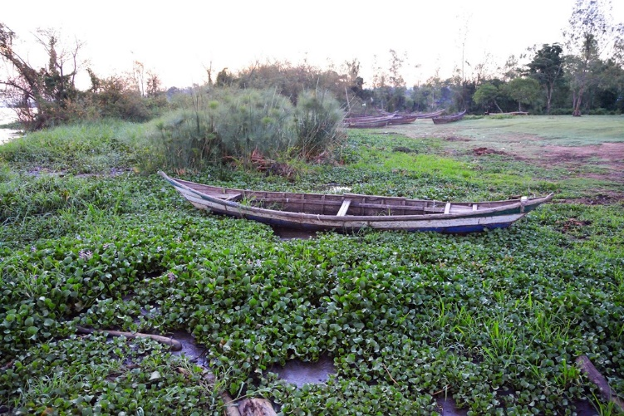
Section of Lake Victoria covered by the water hyacinth.
The policy dialogue
The policy dialogue which was held at Jinja District Council Hall on 26th August 2020 attracted about 40 participants including the Resident District Commissioner (RDC), Chairperson Local Council Five (LCV), District Natural Resources’ Officers from Busoga Sub-region, officials from the Environment Protection Police Unit, Civil Society Organizations, Academicians, Local leaders, the Private sector and Media practitioners. The goal of the dialogue was to discuss and brainstorm on the status of the Lake Victoria hydrology, water quality, livelihoods and other challenges facing the management and utilization of Lake Victoria so as to identify the possible solutions to mitigate environmental degradation of around Lake Victoria basin. The district chairperson of Jinja district local government noted that the lake is faced with increasing encroachment from investors and industrialists who are in most cases aided by powerful politicians to acquire land titles in the buffer zones of the lake, forests and wetlands near the lake. The chairperson blamed both the central and local governments surrounding the lake for negligence that has resulted into encroachment and pollution of the lake. In terms of policy implementation, it was observed that although Uganda boosts of good laws, implementation of the laws is very poor. This is mainly brought about by inadequate funding of the regulatory bodies, inadequate capacity and equipment to use in the monitoring of the lake and lack of coordination among the countries that share the lake. Illegal settlements and fishing activities were also noted as factors that affecting the lake and have led to reduction in the fish catch leading to unemployment and loss of government revenue from fish exports.
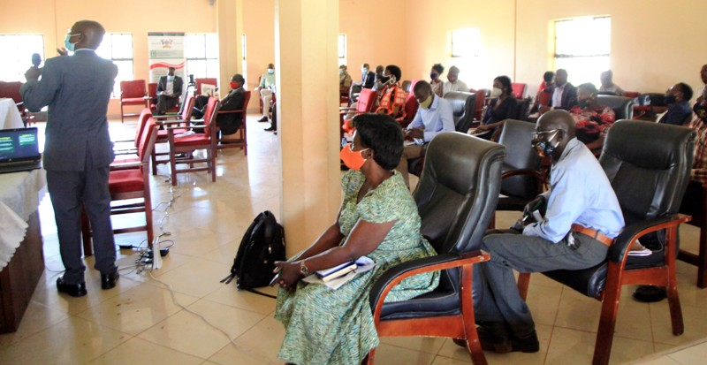
A section of participants attentively listening to Prof. Edward Bbaale, Director EfD Mak Centre.

According to the Director EfD Mak, climate change has also affected the basin as temperatures have consistently increased between 0.1°C and 2.5°C, basing on the historical data from 1920 to 2013. Increases in annual rainfall totals have been identified and projections indicate that annual mean temperatures could increase by 0.5 to 3⁰C by 2050. Under the most pessimistic scenario, these increases could be some 3 to 5⁰C by 2090. Projections for rainfall are more uncertain and vary between seasons, with some models showing increased rainfall while others show decreased rainfall totals (Seema and Oppelstrup, 2020). The Lake Victoria basin and its inhabitants are vulnerable to the increasing effects of climate shocks, which would likely exacerbate its environmental problems as witnessed recently with water overflows of the lake given that Lake Victoria is shallow and the moving islands on the lake. The basin has a history of floods and droughts, with short and long-term consequences for communities. Such extreme events worsen environmental problems such as land degradation and deteriorated water quality. Increased rainfall variability and changes to the timing of the rainy seasons affects agricultural production and place more pressure on natural resources and drive further encroachment of wetlands and other environmentally sensitive areas through climate-change induced migration. In recent decades, some of the rivers and streams serving the lake and its near-shore areas have become particularly polluted by partially treated municipal waste, industrial effluents, urban surface contaminated runoff, and raw sanitary effluent from people’s settlements. Most lake nutrients originate from organic and inorganic waste for intensive agricultural activities, municipality or town sewage, and livestock. Rivers carry industrial discharges directly draining along the lake shoreline. Malfunctioning sewage plants discharge inadequately treated sewage into rivers and only to be discharged into the lake. The agricultural and chemical industries discharge pollutants directly into the lake. On the Tanzanian side for example, small-scale gold mining activities were observed to have increased potential sources of heavy metals, pesticides and nutrient-rich effluents in the lake. Heavy metals originating from urban settlements and remote inland areas, food processing, textile, leather, paper production, and metallurgy industries in Jinja as well as pollution from Murchison Bay adversely affect the Uganda’s side of the Lake. Wetlands are natural water purifiers, however, over the years, the Lake has lost much of its shore’s wetland cover due to human activities. There has been progressive degradation of the catchment area through farming, deforestation, overgrazing, settlements and other income generating activities. This results in high sediments, transport and other pollutants to the lake ecosystem due to the removal of buffering effect of the wetlands’ macrophytes. In addition, the fish catch from the lake has been reducing over the years especially the Nile perch which has greatly affected livelihoods including employment and government revenue. Hence, there is need for quick action to protect the original biodiversity in the Lake Victoria Basin to safeguard the communities’ welfare which is at stake and ensure sustainable use of the Lake Victoria.
Measures for sustainable use and management of Lake Victoria Basin
From the dialogue, the following were proposed as measures to ensure efficient management and use of Lake Victoria: Protection, preservation and restoration of Lake Victoria biodiversity should become part of an integral lake basin plan. Particularly, the influence of upstream activities on the Lake should be proactively regulated and the guidelines for controlling nutrient influx and fishing pressure established and implemented through both sensitization, dialoguing and strict enforcements of the law. Any attempt to conserve habitats and biodiversity in the lake will succeed only if the general environmental quality permits. Efforts to ensure this should include maintenance and restoration of water quality in the lake, its tributaries, and the associated wetlands. Local governments surrounding the lake should formulate and pass ordinances and bi-laws to protect the lake basin. There is need for a biological monitoring system based on elements of the indigenous flora and fauna of the lake including fish stock management strategies to prevent exhaustion of some fish species. The same should be done to other lakes in Uganda such as lake Albert and Kyoga among others including encouraging fish farming to reduce pressure on the natural lakes. The maintenance of wetlands in the basin is critical for both ecosystem services and conservation of indigenous species. This should be followed by economic valuation of all lakes, rivers, wetlands and other natural resources in the country. Transboundary cooperation on the Lake Victoria Basin management and tackling of both non-point source pollution through sustainable land and water management and sustainable fisheries and lake management, and point source pollution through improved municipal wastewater and sanitation management and industrial pollution control need to be deepened. A coherent plan for conservation and rehabilitation of the Lake Victoria fish fauna should be developed. The plan should entail provisions for halting and reversing eutrophication and for setting up reserves that typify the various habitats of the lake and its tributary rivers, associated wetlands, and satellite lakes. It must also consider the human aspects of such reserves through consultation with local groups. The plan should be incorporated into more general policies for the management of the fishery and for the wide range of other human activities in the lake basin. The local community and local leaders should be empowered and involved by the authorities in the protection of the lake from destruction and bad fishing practices. Massive campaigns about proper disposal and treatment of both liquid and solid waste in eco-friendly way should be encouraged. Buffer zone size of 200m away from the lake should be emphasized and strictly enforced and there should be argent mapping of flood risky areas/zones of Lake so as to adjust the buffer sizes where necessary. The fight against climate change should not be ignored and thus the government should launch a plan to plant trees along all roads and also native shrubs/trees along all the lakes & river buffer boundaries in the country. For the socio-economic aspects, landing sites and communities especially those that were so much affected by recent floods, buffer zone evacuations and resettlements should be supported in terms of relief packages, because if not supported, these people are most likely to re-encroach the protected zones.

Conclusion
Nature is talking and thus, we need to listen. “Humanity can forgive and forgets but nature neither” said Pope Francis II. Effective management of Lake Victoria Basin requires participation of all stake holders, local leaders and the community in the basin and all countries that share the lake. The ongoing degradation and pollution of Lake Victoria should be treated as an emergency case just as COVID 19 pandemic to ensure that the lake biodiversity, ecology, species and boundaries are protected. The government should take lead in sensitizing the masses, training environmental policy makers and regulators and media on the importance of conservation and sustainable use of Lake Victoria. In addition, the government should increase its budget allocation to the environmental and natural resources’ sector and ensure that the sector is well equipped with skilled, capable and incorruptible human resource and monitoring equipment.

Acknowledgement

The policy brief was written by Peter Babyenda on behalf of EfD Makerere Centre.
References
Awange, J.L., Gebremichael, M., Forootan, E., Wakbulcho, G., Anyah, R., Ferreira, V.G., and Alemayehu, T. (2014). Characterization of Ethiopian mega hydrogeological regimes using GRACE, TRMM and GLDAS datasets. December 2014. ISSN 0309-1708. Adv.Water Resour. 74, 64–78.
Njiru M., John Gichuki , Charles Ngugi and L. Muhoozi. (2008). An overview of the current status of Lake Victoria fishery: Opportunities, challenges and management strategies. Lakes & Reservoirs: Research and Management 2008 13: 1–12
Seema, P., and Oppelstrup, J. (2020). Hydro-meteorological processes driving solute transport in Lake Victoria, Water Science, 34:1, 18-31
Soesbergen, A., Sassen, M., Kimsey, S., and Hill, S. (2019). Potential impacts of agricultural development on freshwater biodiversity in the Lake Victoria basin. Aquat. Conserv. Mar. Freshw. Ecosyst. 29, 1052–1062. https://doi.org/10.1002/aqc.3079.

