**Household nutrition effects of crop commercialisation in Uganda**

**November, 2019**

**RESEARCH BRIEF**

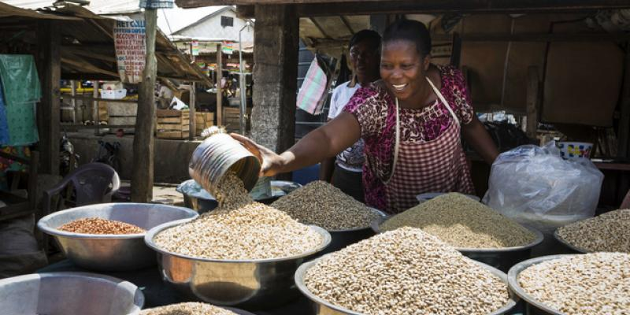

***Key findings***

* *While commercialisation has contributed towards increasing agricultural income, its impact on nutrition has been adverse as neither production nor the accrued income resulted in nutrition sensitive consumption;*
* *Agricultural policies and programmes seem to have focused more on market oriented production and less on nutrition sensitive agriculture;*
* *There is inadequate nutrition knowledge among the population as no significant difference between nutrient intake of the more educated and higher income households and the less educated low income households was found;*
* *While rural households potentially stand to gain more from the policies and programmes, they need support in order to gain from them as they lack the capacity to orient their production towards the market, confining them to subsistence agriculture;*
* *Presence of agricultural markets was found as crucial for both commercialisation and household nutrition, reinforcing the need to develop more such infrastructure.*

***The research***

Agricultural commercialisationis seen as a pathway towards rural economic transformation since it is not only expected to improve income, but also enhance a wide array of other welfare indicators such as nutrition. Big gains are expected especially among rural households whose livelihood is directly derived from agriculture. In the anticipation of the attendant benefits, many developing countries have embarked on agricultural commercialisationas a growth strategy. Objective 3 of Uganda’s Agricultural Policy is to to *"promote specialization in strategic, profitable and viable enterprises and value addition through agro-zoning"*.

This is informed by the understanding that commodity specialization and agro-zoning strengthen agri-business, enhance profitability and market access, leading to the creation of farm and off-farm employment. The creation of additional employment opportunities necessitates increased commercialisation of agriculture and the establishment of industries for value addition to agricultural products (GoU, 2013). This drive has seen the establishment of programmes such as the Poverty Eradication Action Plan (PEAP), the Plan for Modernization of Agriculture (PMA), the National Agricultural Advisory Services (NAADS), the Rural Development Strategy (RDS), and the Prosperity for All programme. This research uses a control function on a nationally representative LSMS-ISA dataset to analyse how such government policies and programmes aimed agricultural commercialisationhave contributed to house nutrition via the intake of calorie, proteins, calcium, zinc, iron and vitamin A.

While commercialisation efforts have been accompanied by policy reforms aimed at creating competitive agricultural markets, there is evidence which emphasizes that commercialisationmay not yield the desired welfare impact. This is likely to be the case for especially the poor households that are positioned at the bottom of the income ladder (Carletto et al., 2017). The debate on the welfare gains from commercialisation comes at a time when government policies and programmes which have seen the expansion of production of commercial crops are being met with mixed reactions. Essentially, the potential welfare gains from commercialisation are being put to question. For instance, the scaling up of sugarcane production has been met with concerns of increasing food insecurity, malnutrition and rising poverty as the extensive nature of sugarcane production requires considerable acreage for farmers to break-even. The resulting increase in demand for land has inevitably pushed households into allocating nearly their entire landholdings to sugarcane, leaving almost none to food production (Mwavu et al., 2018). In their study of the food security implications of expanded sugarcane cultivation among smallholder farmers, Mwavu et al. (2018) show that households in sugarcane production are food insecure, as they lack the means to sufficient food to meet their dietary needs. Home gardens in the sugarcane producing regions were reported to have be rapidly lost important and nutritious food crops like cowpeas, soybean, aerial yams, and bambara groundnuts. This has serious implications for household food security and nutrition. As a result, households were reportedly resorting to offering labour in exchange for food, borrowing, rationing, and at times using unsavoury survival strategies such as stealing from their neighbours.



**Figure 1:** Link between agricultural commercialisation and household nutrition

**Source:** Adopted from von Brown et al. (1990); Ogutu et al. (2017)

***Conclusion***

Overall, commercialisation generally presented negative effects on nutrition. In addition, nutrient intake was found to depend on several pathways such as the amount of resources available, the choice of what is produced, presence of markets as well as how decisions concerning production and consumption are made. It is thus important to understand first, the socioeconomic and cultural setting before identifying the channels for impact.

**ABOUT THIS BRIEF**

This policy brief was written by Nicholas Kilimani, Research Fellow, Environment for Development (EfD-Mak) Centre-Makerere University, Kampala-Uganda. The research was funded by the Bill and Melinda Gates Foundation grant to the African Economic Research Consortium (AERC) under a thematic research project on evaluating the impact of agricultural and food policies on nutritional outcomes in sub-Saharan Africa, Grant RT18532. The author would like to thank the AERC, its reviewers and Resource Persons for their comments on the earlier drafts of the paper from which this Brief was extracted. The Discussion Paper was presented at the Economic Society of South Africa Biennial Conference, 3-5th September, 2019 at the Birchwood Hotel and Conference Centre in Boksburg, Johannesburg-South Africa.

**FURTHER READING**

GoU (2013). National Agriculture Policy, Ministry of Agriculture Animal Industry and Fisheries, Entebbe-Uganda.

Carletto, C., Corral, P., and Guelfi, A. (2017). Agricultural commercialisationand nutrition revisited: Empirical evidence from three African countries. Food Policy, 67:106-118.

Mwavu, E.N., Kalema, V.K., Bateganya, F., Byakagaba, P., Waiswa, D., Enuru, T., and Mbogga, M.S. (2018). Expansion of commercial sugarcane cultivation among smallholder farmers in Uganda: Implications for household food security. Land, 7(2), 73. doi:10.3390/land7020073.

Von Braun, J., Kennedy, E., and Bouis, H. (1990). Commercialisationof smallholder agriculture: Policy requirements for the malnourished poor. Food Policy, 15(1), 82–85. doi:10.1016/0306-9192(90)90027-w.

Ogutu, S., Gödecke, T., and Qaim, M. (2017). Agricultural commercialisationand nutrition in smallholder farm households. Global Food Discussion Papers 97, Universität Göttingen. http://hdl.handle.net/10419/161624.

**CONTACT**

Dr. Nicholas Kilimani, Research Fellow, Environment for Development (EfD-Mak) Centre-Makerere University, Kampala-Uganda, e-mail: nkilimani@cis.mak.ac.ug