Soil Conservation Practices and Neighborhood Effects
How Sustained are the relationships?

This brief is based on EfD Discussion Paper 22-08, “Exploring the Evidence for Inward Diffusion of Soil Conservation Practices among Farmers in Nigeria: A Spatiotemporal Analysis,” by Nkechi S. Owoo and Monica P. Lambon-Quayefio (University of Ghana, Department of Economics, Legon-Accra) and Ebele Amaechina (University of Nigeria, Nsukka, Department of Agricultural Economics), May 2022

Introduction
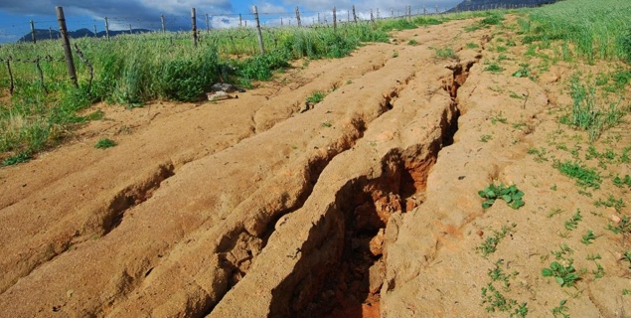

Soils in Nigeria are naturally prone to erosion, and deficient agricultural practices have exacerbated the high erodibility of the soils in the region, leading to deep gully sites, particularly in the southern geographical zones. Land degradation represents a real cost to society as well as to individual farmers, as it reduces crop yields and raises the levels of inputs such as fertiliser (and therefore the costs) required to restore productivity.

In addition to farm and farmer characteristics such as age, education, access to agricultural extension services, and household wealth, questions remain as to whether location and neighbourhood effects play a role in farmers’ adoption of soil conservation practices, such as mixing legumes with whole and planting a cover to preserve the soil.

We assess the role of social networks in the diffusion and adoption of soil conservation practices over space and time in Nigeria. While studies have explored immediate effects of neighbours’ behaviour in soil conservation practices, less attention has been paid to how persistent these effects may be over time.

The presence of neighborhood effects may affect conservation adoption through interactions with neighbouring farmers, which may affect a farmer’s decisions through social learning and influence. Evidence of current and sustained neighbourhood effects would form a strong basis for policy makers to develop effective ways to share information about sustainable agriculture among farmers.

Data and Methods

The study used 2010/2011, 2012/2013 and 2015/2016 waves of the World Bank’s Living Standards Measurement Survey Integrated Surveys on Agriculture (LSMS-ISA) for Nigeria; this is a nationally representative dataset of 5,000 households in each wave. Over 95% of plots in the sample are owned/operated by household heads and therefore, the analyses are conducted at the household (head) level.

We explore the importance of neighbourhood effects on local farmers’ adoption of soil conservation practices (i.e., mixed cropping and cover crop farming), and whether these effects are sustained over time.

Key findings
The figure below shows that soil conservation activities (i.e., mixed cropping) in the south-south and northwest regions of the country in 2015 are influenced by high prevalence of neighbours’ activities in 2012. Similarly, low prevalence of soil conservation activities in the middle belt of the country are correlated with similarly low activity levels of farmers’ neighbours in the preceding period.
Figure 1: Mixed cropping (2012/2015)
Similarly, in Figure 2 below, farmers with high (low) legumes cultivation in 2015 were surrounded by other farmers with similarly high (low) cultivation in 2012.

Figure 2: Legume cover (2012/2015)
Preliminary evidence therefore suggests that farmers in Nigeria learn from each others’ soil conservation practices. We also find that soil conservation practices in any given year are influenced by soil conservation practices of neighbours in earlier time periods.
Policy recommendations/ Call to action
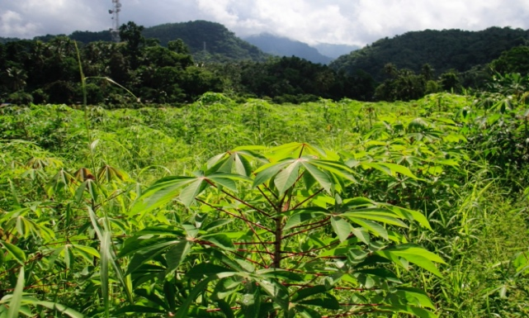
This project explores social interactions and influence over time and across space as an important channel for positive soil conservation practices. The results can be useful for the appropriate targeting of necessary interventions. The study is expected to feed into the knowledge base for directing actions and programmes to promote soil conservation in Nigeria.

References
Läpple, D. and Kelley, H. (2014). Spatial Dependence in the Adoption of Organic Dry Stock Farming in Ireland. European Review of Agricultural Economics, 42(2): 315-337.
Miheretu, B. A. and Yimer, A. A. (2017) Determinants of farmers’ adoption of land management practices in Gelena subwatershed of Northern highlands of Ethiopia. Ecological Processes 6 (19).
Oguike, P.C. and Mbagwu, J.S.C. (2009). Variations in some physical properties and organic matter content of soils of coastal plain sand under different land use types. World Journal of Agricultural Sciences 5 (1): 63-69.
Teklewold, H., Mekonnen, A., Kohlin, G. (2018) Climate change adaptation: A study of multiple climate-smart practices in the Nile Basin of Ethiopia. Climate and Development 11: 180–192.
Tessema, Y. M., Asafu-Adjaye, J., Kassie, M. and Mallawaarachchi, T. (2016). Do neighbours matter in technology adoption? The case of conservation tillage in northwest Ethiopia. African Journal of Agricultural and Resource Economics 11(3): 211-225
Wollni, M. and Andersson, C. (2014). Spatial patterns of organic agriculture adoption: Evidence from Honduras. Ecological Economics 97: 120–8.

Funding
This research work was carried out with financial support from the Environment for Development (EfD) Research fund [Grant No.: MS 961].

