Makerere launches new program dubbed, “Inclusive Green Economy (IGE) in Practice” - Holds its first workshop with the selected senior public servants.

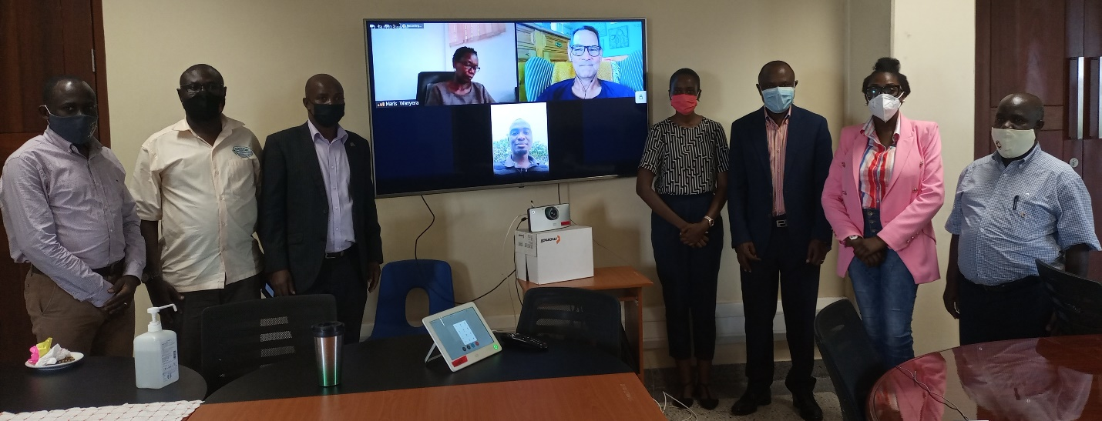
Participants posing for a group photo after the training: Photo: EfD-Mak centre

Makerere University has launched a new program dubbed “Inclusive Green Economy (IGE) in Practice”. IGE in Practice, is a collaborative programme between Makerere University’s Environment for Development Initiative (EfD-Mak) Center and the University of Gothenburg, Sweden fully funded by Swedish Development Agency (Sida). Other participating countries are Ethiopia, Kenya, Tanzania and Rwanda.

The program is aimed at strengthening Uganda’s capacity for transformation towards an Inclusive Green Economy largely under the United Nations SDG 8 that focuses on promoting sustained, inclusive and sustainable economic growth, full and productive employment and decent work for all.
IGE in Practice will focus on the use of environmental policy instruments, and specifically economic instruments such as environmental taxes, pollution fees, subsidies or subsidy reduction and other types of fiscal incentives for societal development in line with the Global Agenda 2030.

The program is an advanced in-service training with direct applicability in the participants’ daily work involving theoretical training within IGE, practical exercises, project development and support for implementing own change work.

The official program launch and training was held at at Makerere University’s Central Teaching Facility 2 (CTF2) on 4th June, 2021 with six (6) selected senior public servants competitively selected among the 19 participants nominated through the Permanent Secretary, Minsitry of Finance, Planning and Economic Development and relayed via zoom to other participants.

The selected senior public servants were from the Ministry of Finance, Planning and Economic Development, Ministry of Water and Environment, the National Planning Authority and the National Environment Management Authority.

These selected public servants will undergo a one year course (running from June 2021 to June 2022) and upon successful completion, given a title of IGE fellows and are expected to became IGE change agents and IGE trainers in their different Ministries, Departments and Agencies.
The function was also attended by the Principal, Makerere University College of Business and Management Sciences (CoBAMS) Prof. Eria Hisali, the Director EfD-Mak Centre who is also, Dean, School of Economics Prof. Edward Bbaale and Makerere University IGE program support team - Dr. John Sseruyange, Lecturer in School of Economics and Mr. Peter Babyenda the Policy Engagement Specialist in charge of coordinating the training program. These were joined by Prof. Anders Ebkom, the IGE program head at the University of Gothenburg, Sweden. .
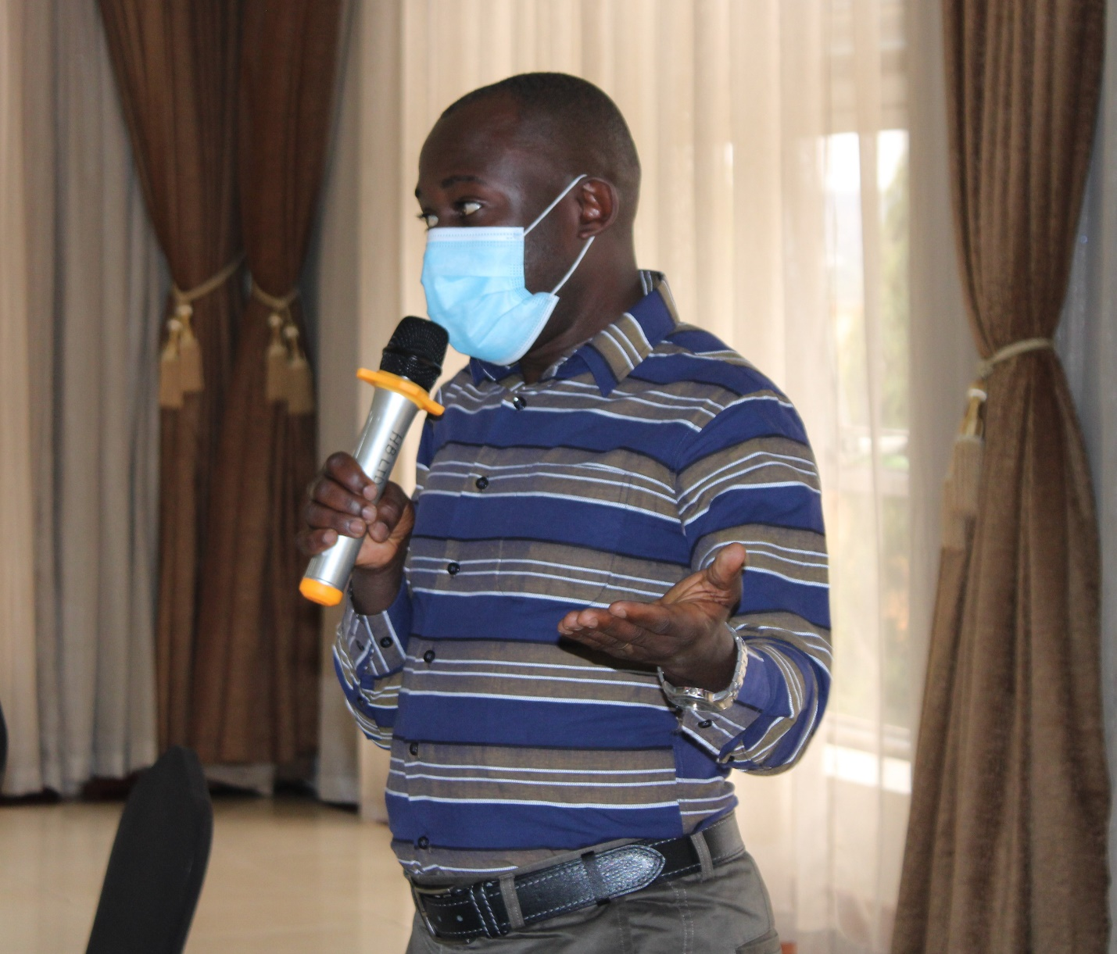

Mr. Peter Babyenda in charge of coordinating the IGE training program : Photo EfD-Mak Centre
In his opening remarks, the Principal CoBAMS Prof. Eria Hisali said the future for sustainable growth across the global is in Inclusive Green Economy, a new phenomenon, yet to be fully tapped into. He thanked the donors for putting trust in the university assuring them that they shall rise to the task that they are taking up.
Prof. Hisali underscored the importance of IGE as extremely important in the case of Uganda and across the developing world presenting a number of opportunities and areas of interest to harness such as Water, Agriculture Energy that have been adequately taken care of in the planning frame work under the National Development Plan of Uganda.
“The vast potential in the area of Renewable Energy; we have a potential to produce up to around 6000mega watts of renewable energy, and yet what has been exploited as of now is under 500mega watts so, there is quite a big potential in the renewable energy in Uganda.
The good will we still have with the donor community, Inclusive Green Economy naturally includes among others tapping into the appropriate technology, good technology and value addition”, The Principal said.
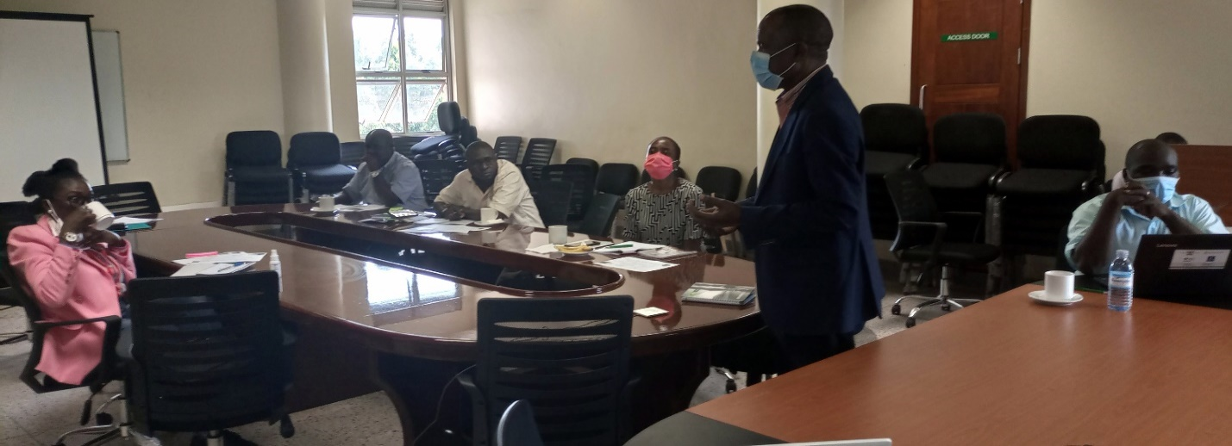Prof. Eria Hisali (standing) giving opening remarks to the selected participants during the program launch: Photo: EfD-Mak Centre
rof. Hisali noted that although there are a number of opportunities and initiatives available in the Inclusive Green Economy, the concept is still new across the private and public arena. He implored the university IGE team to ponder on the issues such as stakeholder coordination, engagement, and involvement.
“... Even when you sample across the public and the private sector, not everyone would appreciate the concept in the same way. The coverage is still limited. How do we get the different stake holders on board? How do we exploit now the untapped potential in terms of an Inclusive Green Economy?
The development philosophy of Uganda is largely the private Sector, will naturally play a very big role in driving the development process. Therefore, the question here is how do we incentive the private sector to take up these different aspects of Inclusive Green Economy investments.
There are a number of initiatives under Inclusive Green Economy investments which are across the country both in the private and public sector. There are different sectors in different locations. How do we plan to coordinate these sectors?” Prof. Hisali questioned.
The Director, EfD-Mak Center who is also part of the support team of Inclusive IGE Assoc. Prof. Edward Bbaale introduced EfD as a global network of Environmental Research Centers comprising fifteen centers across the world coordinated in the EfD Secretariat, a special unit in the School of Business, Economics and Law at the University of Gothenburg Sweden.
Prof. Bbaale said the EfD impact modal values a lot academic training which feeds into the Applied Research and also, institutional development which ultimately leads to Research Policy interaction and then the realization of an impact.
The Director said the meeting was about Inclusive Green Economy in practice, a capacity building program where the trainees will be equipped with information about the IGE Program, what it is about, why IGE, what the training will cover and the role of the centre and the trainees.
Prof. Bbaale expressed the need to ensure commitment by the participants on the program tasks and also connect with each other and understand each other’s roles.
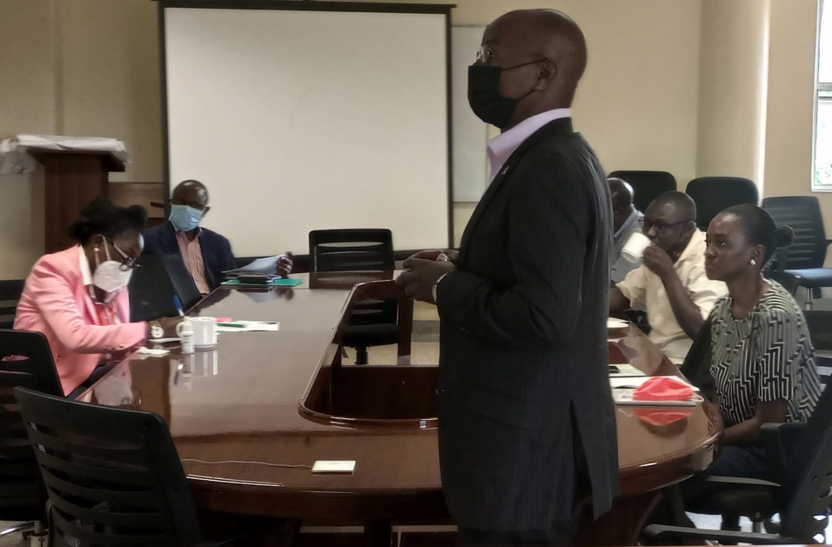
Assoc. Prof. Edward Bbaale explaining the road map of Inclusive Green Economy during the launch. Photo: EfD-Mak centre

He reported that the first round of this program will run from May 2021 up till March 2022 and targets the senior civil servants mainly the economists. In Uganda. Prof. Bbaale said 19 participants were recommended but 6 were selected but the program too has a regional focus with 5 participants from Kenya, Rwanda with 6, then, Tanzania and Ethiopia with 6.
“The main objective is to strengthen East African countries capacity to transform into an Inclusive Green Economy through; Increased knowledge and Application of Economic and Environmental policy instruments; Organizational change, how do we change the organizations where we work to make sure that we are well aligned in the inclusive Green Economy agenda and; Strengthen National systems for Inclusive and sustainable Economic development”, Bbaale said
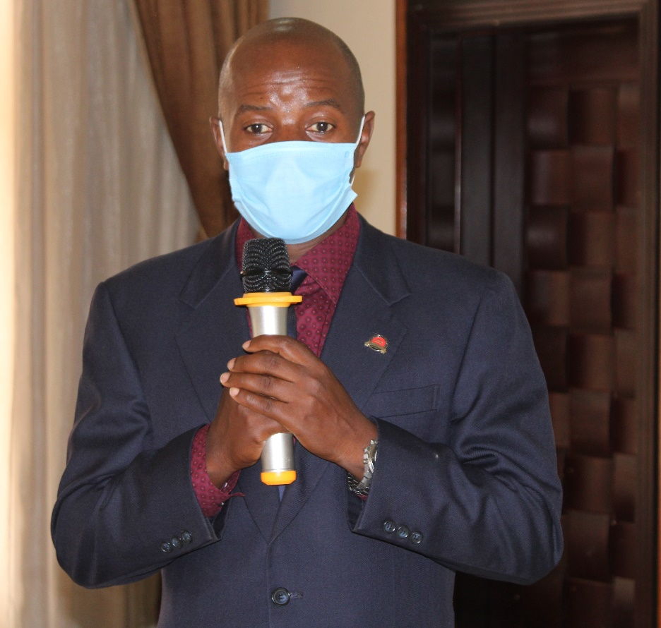
Director EfD-Mak Centre Assoc. Prof Edward Bbaale speaking: Photo: EfD-Mak centre
In the program out line, Prof. Bbaale said, phase 1 in March –April 2021was a call for applications and phase 2 is the startup meetings which was being done and running according to plan. In phase 3 there will be trainings on the Inclusive Green Economy aspects, theories and practices.
Prof. Bbaale reported that Phase 4 shall have the Golden thread called the Inclusive Green Economy Project where each participant will have to design a project in their different organizations intended to show how they can change their organizations and how well they can align themselves in a Green Economy.
In the same phase 4, the Director said, there will be support workshops, high level policy workshops, support meetings from the mentors and the peer running reviews followed by regional course between October and March 2022 and then national workshops.
“This program is an advanced in-service training with direct applicability, where participants will get great understanding, knowledge and ability to critically review and analyze the current economic policies and conditions while at the same time find opportunities for transformation towards a Greener Economy. Therefore, this means you are a change agent in your organization, the training will strengthen the role of the participant as a change champion.
The program is organized by the UGOT, the center for sustainable development in collaboration with several expert organizations and Makerere University being part of that under the EfD- Mak Center. A team of experts and Lecturers include; those from Sweden but also other international experts with extensive experience.
The program is fully funded by the Swedish International Development operational Agency (SIDA). All costs are covered by the UGOT. Therefore, the participants will only contribute their time.” Prof. Bbaale added.
Prof. Bbaale highlighted some of the benefits from the program at individual level, organizational and at the system level that combines the entire country.
At individual level he said, there is peer to peer learning, understanding the inclusive green economy, its usefulness, risks and opportunities of applying these economic instruments, and increased knowledge of organizational change, how does one start up the change at organization level and how to build network efforts at international level.
At organizational level; he explained that one will benefit by building capacity on behalf of the organization in the area of Inclusive Green Economy; Application of economic instruments and increased priority on Inclusive Green Economy and the Introduction of Inclusive Green Economy or economic instrument projects and support of the ongoing IGE projects.
At national level, he said the benefits range from Strengthened National systems for green economic transformation; Improved cooperation between government agencies and across countries of collaboration and; Enhanced application of green economy analysis and economic instruments for IGE transformation
Program Training Methodologies
In terms of training Methodologies, the Director said, these shall include; advanced professional capacity building program, which will have action learning methodologies online; under that shall have online meeting place for professionals in planning and policy development strategic and resource green economy.
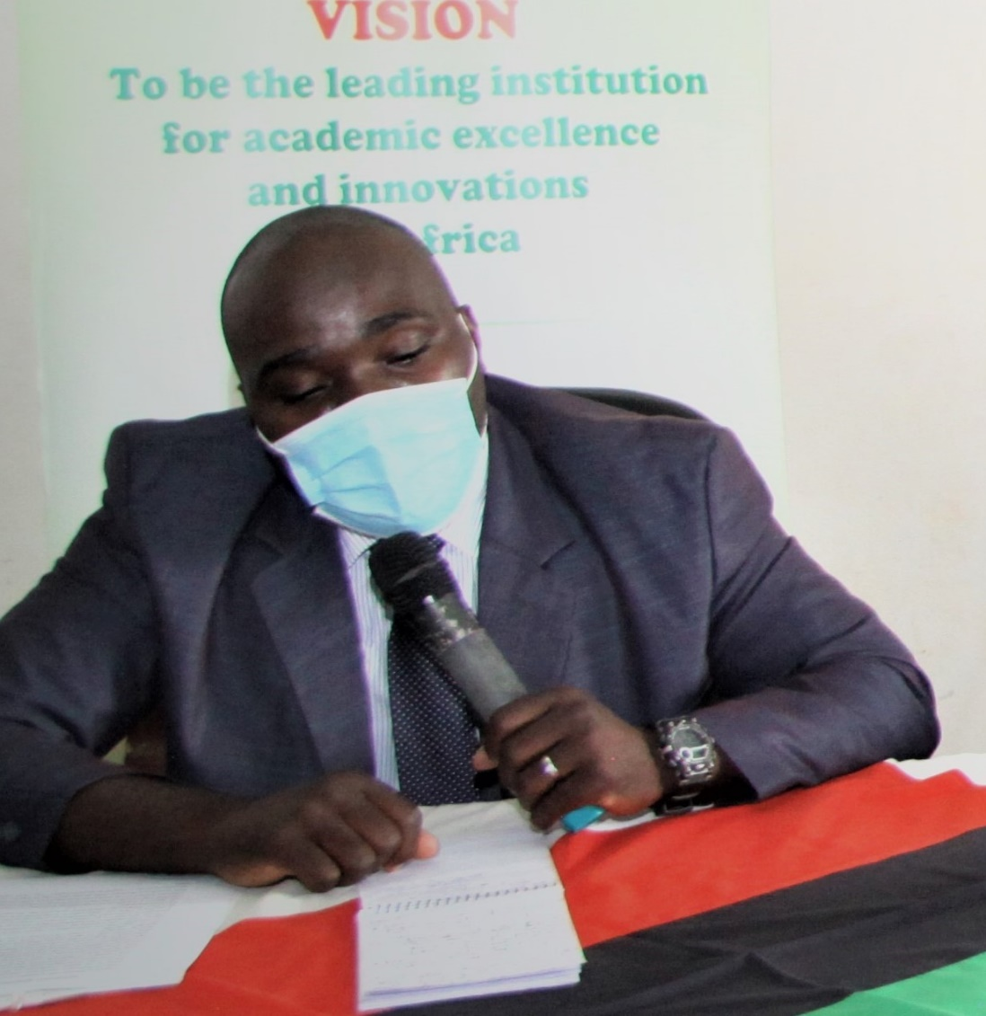
Dr. John Sseruyange, Mak IGE support team member. Photo: EfD-Mak Centre
Since it is going to be an action learning experience, part of it shall be exchange of knowledge and sharing of experiences. There shall be interaction in terms of group work, discussions, joint learning i.e. on line and then develop the Golden Thread – the Inclusive Green Economic Project which will be developed from the different organizations.
The Program Tasks according to Prof. Bbaale include participation in the training, developing and implementing the Inclusive Green Economy Project and conducting and participating in National policy review workshops for peer learning.
As part of the tasks; one will be a trainer and as a participant, one will be given a title of Inclusive Green Economy Fellow (IGE-Fellow) which will distinguish one from those that have not undergone this program.
As a Fellow, one will be required to actively involve the workmates/colleagues where one will form a team at their place of work with in their organization. One will work on experiences and work projects and actively contribute on their own expertise and experiences.
One will in addition manage development and implementation of a number of tasks through the 10months of the program duration and upon graduation and successful achievement of all tasks, one will be awarded a certificate and become part of the IGE-Fellow networks or program alumni.
All IGE-Fellows are assigned a support team which includes; Country Academic partners and expert advisors on Inclusive Green Economy.
Prof. Bbaale said, the role of the support team is to; Provide feedback on ones assignments and tasks, offer advice on critical questions, support and encourage one to keep moving on the program. This support team understands the Inclusive Green Economy processes, changes process and organization capacity program and they will challenge, coach , encourage and also critically review the written tasks and helps fellows with the information sharing and IGE networking.
Program Guide for the Trainings
- 10th-11 June as the first training
- 17th -18 June second training
- 9th -10th September third training
- 16th -17th September fourth training
These trainings will be conducted virtually.
Giving his remarks via zoom, the IGE program head at the University of Gothenburg, Sweden. Prof. Anders Ebkom said, Inclusive Green Economy (IGE) is one of the Agenda of 2030 of the Sustainable Development Goals (SDG 8).
He said the rich and poor countries cannot do things the same way for various reasons and that is why development is not sustainable.
“And therefore we cannot go on the way we do. The Rich countries consume too much while the poor countries cannot invest in technologies that are sustainable. Investments are not environmentally or socially and economically sustainable. Our horizons are too short.
Therefore, the agenda is to guide development and this program focuses on SDG 8 which really deals with jobs, decent work but also sustainable economic development,” Prof. Anders Ebkom said
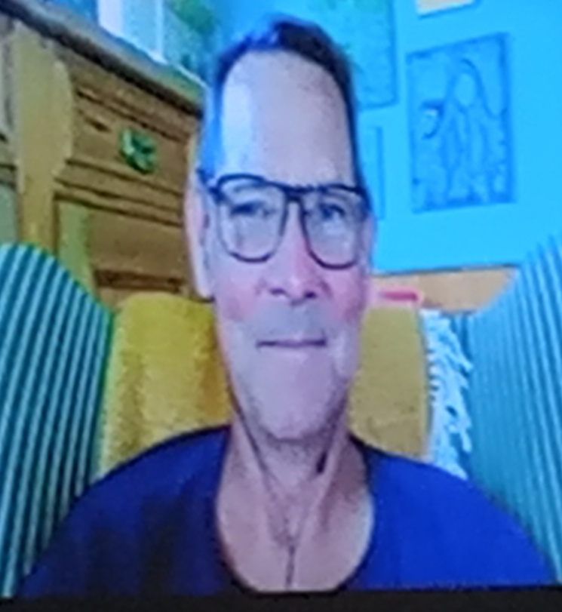
Prof. Anders Ebkom making remarks via zoom: Photo EfD-Mak centre

He said IGE is a practical approach to address and work with SDG8 and that it is broader than just Green Economy because one can go for policies that promote green growth but at the expense of the poor or the marginalized people.
He clarified that, one has to emphasize on inclusion or social acceptance as one designs the green economy policies.
He explained that the SDGs are made up of 5Ps, i.e. Prosperity, People, Planet, Peace and Partnerships where the first three Ps represent Inclusive Green Economy.
In the case of IGE Prof. Anders said there is need to ensure that the economy and the environment are brought together in a large extent.
“The concept of IGE is to bring the social, economic and environmental issues together for integration, inclusion of people in planning, decision making and the outcomes. Environmental sustainability, social sustainability and economic sustainability, the three need to come together so as to have a comprehensive sustainable development”, Prof. Anders Ebkom said.
IGE according to Prof. Anders is made up of several concepts; resource efficiency, system mitigation, system resilience, strong communities and habitants, sustainable economic growth, Inclusive economic growth, equity, poverty reduction, strengthening of rights and social inclusion.
He said the Green economy wants to reduce pollution, reduce inefficiency, reduce waste, economize the natural resources and go for extensive use of natural resources while IGE has to make use of internal policy plans, and other departments as well.
“This does not mean taking over their jobs but rather working together through campaigns and other means.
IGE needs to promote green jobs and sustainable employment. Need to move from the Ministry of Environment and NEMA, and involve the Ministry of Finance because these organizations sit on very powerful tools to manage the environment through economic empowerment.
IGE needs to move away from the victims being paid for polluting the environment but rather have the polluters pay for polluting the environment. That way the environment will be preserved.
Need to move from environmental conservation and protection to sustainable management”. Prof. Anders Ebkom stressed.

